MECA500 ARM

MECA500 ARM

MECA500 Arm API:
- The meca500 arm has a built in API that can be used to help with position testing, movement, and speed adjustments.
- To access this api the arm must be connected to the computer, and powered on.
  - Ensure the emergency stop button on the power supply is set properly and the switch is on.
  - In browser type in arm IP to access the MECA500 API
    - IP: 192.168.0.100

MECA500 User Programming Manual:

https://resources.mecademic.com/en/doc/11.1/Meca500/MC-PM-MECA500/basic-theory-and-definitions.htm

- This manual goes over how to use the API, the range of motion, arm capabilities and limitations, and most importantly coding commands.
**Note: Most commands are in python package but not all**
- Python package: pip install mecademicpy (in powershell)
      - import mecademicpy.robot as mdr

Used MECA500 functions: **More indepth in manual**

ActivateRobot:
    - This command activates all motors (as well as the EOAT connected to the tool I/O port) and disables the brakes of the joints.

DeactivateRobot:
    - This command disables all motors (as well as the EOAT connected to the tool I/O port) and engages the brakes on the robot joints. You must deactivate the robot in order to use certain commands (e.g., SetJointLimits, SetNetworkOptions).

Home:
    - This command starts the robot and MEGP 25* gripper homing process (Section 1.3.1). While homing, it is critical to remove any obstacles that could hinder the robot and gripper movements.

ResetError:
    - This command resets the robot error status.

ResumeMotion:
    - This command resumes the robot’s movement if it was previously paused under one of the following conditions:By the PauseMotion command.Due to a torque overload configured in pause motion mode (see SetTorqueLimitsCfg).By the SWStop (Meca500 R4), which is no longer present.
    - The robot resumes the remaining trajectory from the position where it came to a stop (after deceleration), unless an error occurred after the PauseMotion or the robot was deactivated and then reactivated.
    - The ResumeMotion command must also be sent after the ClearMotion command. However, the robot will remain stationary until another motion command is received or retrieved from the motion queue. Additionally, the ResumeMotion command must be sent after the ResetError command.

MoveJoints:
    - This command makes the robot simultaneously move all its joints to the target joint set, as fast as possible but subject to the limits set by the commands SetJointVel and SetJointVelLimit. All joints start and stop moving at the same time, so there is generally only one joint that moves at the joint velocity indirectly specified in SetJointVel and SetJointVelLimit. The robot takes a linear path in the joint space, but nonlinear in the Cartesian space. Therefore, the TCP trajectory is not easily predictable (Figure 49). Finally, with MoveJoints, the robot can cross singularities without any problem.

MoveLin:
    - This command makes the robot move its end-effector, so that its TRF ends up at a target pose with respect to the WRF while the TCP moves along a linear path in Cartesian space, as illustrated in Figure 49b. If the target (desired) orientation of the TRF is different from the initial orientation, the orientation will be modified along the path using a minimum-torque path.

MovePose:
    - This command moves the robot’s TRF to a specified pose relative to the WRF. The robot controller calculates all possible joint sets corresponding to the target pose, including those associated with singular robot postures. It then selects the target joint set based on the specified robot posture and turn configurations, if provided, or the one requiring the least time to reach.
    - The selected joint configuration is executed internally using a MoveJoints command. As a result, all joint rotations start and stop simultaneously and move as quickly as possible, subject to the limits defined by the SetJointVel and SetJointVelLimit commands. The resulting motion is linear in joint space but nonlinear in Cartesian space, meaning the TCP’s path to its final destination is not easily predictable.

GetStatusRobot:
    - This command returns the status of the robot.

SetTorqueLimitsCfg (not too sure if this was necessary):
    - This command sets the robot behavior when a joint torque exceeds the threshold set by the SetTorqueLimits command. It also sends a torque limit status when the status changes (exceeded or not) for events severity greater than 0. For severity 4, a torque limit error is sent when torque exceeds the limit.

SetTorqueLimits:
    - This command sets thresholds for the torques applied to each motor, as percentages of the maximum allowable torques that can be applied at each motor. These thresholds can be interpreted in two different ways:
    - When the second argument of SetTorqueLimitsCfg is 0 or 1, the absolute values of the actual motor torques (GetRtJointTorq), also reported as percentages of the maximum allowable torques, are compared to the respective thresholds.
    - When the second argument of SetTorqueLimitsCfg is 2, which is the default setting as of firmware 11.1, the absolute value of the difference between the actual (GetRtJointTorq) and calculated motor torque (GetRtTargetJointTorq) of each joint is compared with the respective threshold. Thus, in this case, the arguments of SetTorqueLimits should be rather small, for example, about 10 (percent).
    - When a torque thresholds is exceeded, a customizable event is created. The event behavior can be set by the first argument of SetTorqueLimitsCfg.
    - This command is intended only to improve the chances of protecting your robot, its end-effector, and the surrounding equipment in the event of a collision. The actual torque in each motor (GetRtJointTorq) is estimated by measuring the current in the corresponding drive. The calculated torque (GetRtTargetJointTorq) is obtained from the dynamic model of the robot.

SetJointVel:
    - This command specifies the desired velocities of the robot joints during movements generated by the MovePose, MoveJoints, and MoveJointsRel commands. It has impact on these movement commands only if if the move mode is velocity-based (see SetMoveMode).

SetJointAcc:
    - This command limits the acceleration of the joints during movements resulting from joint-space commands (see Figure 48). Note that this command makes the robot come to stop, even if blending is enabled.

SetCartLinVel:
    - This command sets the desired and maximum linear velocity of the robot TRF with respect to its WRF. It only affects the movements generated by the MoveLin, MoveLinRelTrf and MoveLinRelWrf commands. It has impact on these movement commands only if the move mode is velocity-based (see SetMoveMode).
  - MoveGripper:
    - The MEGP 25* grippers are equipped with incremental encoders, so it is impossible to directly measure the absolute positions of the gripper jaws. Thus, during the homing of the robot, the gripper is also homed by completely closing and then opening its fingers, until resistance is met in each direction. The maximum fingers opening is detected and is a positive number not larger than 6 mm (MEGP 25E) or 48 mm (MEGP 25LS). Most importantly, the fingers opening, a non-negative distance, is defined as the sum of the distances traveled by each jaw from their fully-closed positions detected during homing.

METTLER XPR105dr

METTLER XPR105dr

XPR105dr help files:

General manual:
https://drive.google.com/drive/folders/1Db2GR28gi8NXJwaBTKw0nh4czgr24eVc

Coding manual: https://drive.google.com/drive/folders/1Db2GR28gi8NXJwaBTKw0nh4czgr24eVc

MICRONIC DT500 BARCODE SCANNER
Micronic DT500

- There is basically no documentation for this device
- It is an automatic plug and play keyboard barcode scanner with no options of changing it to a serial scanner (non keyboard).
- If the device is not scanning:
  - The barcode/QR is of poor quality
    - Use different ones
  - You just powered it back on:
    - Give the scanner a few minutes to boot up as it doesn’t scan right away.
  - The barcode scanner is broken (that's all I can think of).
    - Get a new one 👍

Code:
- IMPORTANT: I made the code so the keyboard of the computer is DEACTIVATED. This is because the scanner will continuously type barcodes into applications open and can just be really annoying.
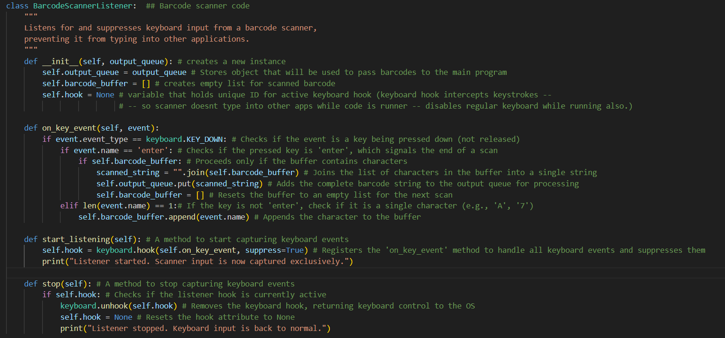

Customer Service
Email: Paazougi19@gmail.com

Topic line: ANUBIS Help

